

The Islamia University of Bahawalpur
Bahawalnagar Campus

SOFTWARE DESIGN DESCRIPTION
(SDD)

For

<Object Identification App>
Version1.0

By

Ayesha Adnan F22NDOCS1M01093

Supervisor
Mr. Shahid

Bachelor of Science in Computer Science (2022-2026)

Table of Contents
Revision History iii
- Introduction 01
- Design Methodology and software process model 06
- System Overview 12
  - General System Description 13
  - Architectural Design 14
  - System Activity Diagram………………………………………………………………………17
- Design Models [along with descriptions] 23
- Data Design 31
  - Data Structure Overview 32
  - Data Dictionary………………………………………………………………………………...33
- Algorithm & Implementation 36
- Software Requirements Traceability Matrix 43
- Human Interface Design 45
  - Screen Images 46
  - Screen Objects and Actions 47
- Appendix I 51

Revision History

Name | Date | Reason for changes | Version

Application Evaluation History

Comments (by committee)  *include the ones given at scope time both in doc and presentation | Action Taken

Supervised by
<Mr. Shahid>

Signature

1

Introduction

Introduction:

1.1 Overview
This Software Design Document (SDD) provides the complete technical design blueprint for the Check-Me: Object Recognition Application. It refines and extends the requirements defined in the Software Requirements Specification (SRS) and converts them into a system-level and component-level design model intended to guide the development team throughout implementation.
Where the SRS describes what the system must do, this SDD focuses on how the system will be built and how its internal mechanisms will operate. It presents the fundamental architectural layers, module decomposition, data flow pathways, interface behaviors, algorithmic processing, and component interactions that collectively form the application’s technical backbone.
This document also aims to ensure design clarity, maintainability, scalability, and alignment with modern mobile development and machine-learning engineering practices. Every design decision is made to support the system’s goals: accuracy, responsiveness, usability, and offline inference capability.

1.2: Purpose of the SDD
The purpose of this Software Design Document is to:
- Translate functional and non-functional requirements into clear technical structures.
- Define the system architecture, including high-level architecture and module-level design.
- Document all significant software components, internal workflows, and inter-module interactions.
- Provide detailed descriptions of algorithms, data transformations, and processing pipelines.
- Serve as a reference document for developers, testers, maintainers, and stakeholders.
- Ensure that the system can be implemented consistently, efficiently, and aligned with industry standards.
This SDD is essential for ensuring consistency in development, managing complexity, and enabling the application to evolve in future iterations.

1.3: Scope of the System
The Check-Me application is a mobile-based object detection system that enables users to capture or upload images and identify the objects present in them using a machine-learning model. The SDD defines the design of all major components required to deliver:
- A responsive mobile interface
- A reliable image capture and processing pipeline
- A high-performance inference engine
- Offline-capable object recognition
- Clean visualization of detection results
- Optional data storage (history, logs)
- Robust system management and error handling
This document encompasses both the frontend (React Native) and backend (Django/Rest API for optional services) design, along with the machine-learning integration using YOLOv8 or equivalent lightweight model formats (e.g., ONNX, TFLite).

1.4: System Architecture Summary
The system follows a modular, layered architecture, with clear separation of concerns:
- Presentation Layer — User Interface Module
- Acquisition Layer — Image Acquisition & Pre-processing
- Inference Layer — Object Recognition Engine (YOLOv8 Integration)
- Logic Layer — Result Processing Module
- Data Layer — Storage & Logging
- Management Layer — System Management Services
Each module communicates through well-defined interfaces, ensuring flexibility and maintainability.

1.5: Modules Covered in This SDD
Below is the expanded version of the modules described in your original text. Each module now includes deeper design detail suitable for an SDD.

Module 1: User Interface (UI) Module
The User Interface module manages all direct interactions between the user and the system. It is built using React Native, ensuring cross-platform support for Android and iOS.

Responsibilities:
- Displaying interactive screens including home, capture, gallery selection, preview, and results.
- Providing navigation flow between UI components using a stack navigation model.
- Showing real-time camera feed and handling user tap gestures.
- Displaying annotated images with bounding boxes and detection labels.
- Presenting confidence scores and formatted detection summaries.
- Ensuring accessibility with proper button sizes, color contrast, and readability.
- Rendering system notifications, warnings, permissions prompts, and error states.

UI Screens:
- Home Screen
- Camera Input Screen
- Gallery Selection Interface
- Processing/Loading Screen
- Detection Results Screen
- History/Logs Screen (Optional)
- Error/Notification Pop-ups
The UI strictly follows consistent design themes and uses vector icons for clarity.

Module 2: Image Acquisition Module
Responsible for input acquisition from camera and device storage.

Responsibilities
- Integrating with device Camera API for real-time feed and high-resolution capture.
- Invoking the OS gallery through the file-picker API.
- Handling necessary permissions (camera, storage).
- Parsing and loading images from device storage.
- Passing acquired images to the Pre-processing Module.

Module 3: Object Recognition Engine
This is the core computational module responsible for running machine-learning inference.

Responsibilities
- Loading the YOLOv8/TFLite/ONNX model on device.
- Initializing interpreters and allocating memory buffers.
- Performing forward-pass inference on input tensors.
- Generating bounding boxes, class IDs, and confidence scores.
- Handling both offline and optional backend-based inference.

Technical Design
- Uses model wrappers for platform-specific inference:
- Android (Java/Kotlin Native Modules)
- iOS (Swift/Objective-C Native Modules)
- Uses numeric optimization (quantized models) for faster execution.

Module 4: Pre-processing Module
Responsible for ensuring the image is compatible with model requirements.

Responsibilities
- Image resizing to target dimensions (e.g., 640×640).
- Normalization (scaling pixel values).
- Aspect-ratio management (padding/cropping).
- Converting images to tensors.
- Color-space adjustments (RGB conversion).

Module 5: Result Processing Module
Handles interpretation of raw model outputs.

Responsibilities
- Decoding model output tensors.
- Filtering overlapping detections (Non-Maximum Suppression).
- Removing detections below a confidence threshold.
- Mapping numeric class IDs to human-readable labels.
- Preparing structured detection objects for the UI.
- Drawing bounding boxes using React Native image overlay tools.

Module 6: Data Logging & Storage Module
Supports optional local storage and analytics needs.

Responsibilities
- Storing detection history (images, labels, timestamps).
- Managing recent scans and cached results.
- Storing user preferences (theme, permissions).
- Handling storage cleanup and lifecycle.
- Technologies
- Local storage: SQLite, AsyncStorage, or FileSystem APIs.

Module 7: System Management Module
Handles background tasks and operational stability.

Responsibilities
- Managing app lifecycle (foreground/background).
- Maintaining model availability and version updates.
- Handling exceptions and unrecognized inputs.
- Managing permission requests and OS dialogs.
- Monitoring device resource usage and performance constraints.
This module ensures the app remains stable, responsive, and reliable across varied device conditions.

2

Design methodology and

Software process model

The design methodology selected for the Check-Me: Object Recognition Application is Object-Oriented Design (OOD), implemented using Object-Oriented Programming (OOP) concepts. This methodology aligns with the system’s modular nature, supports long-term maintainability, and simplifies the integration of machine-learning components. Due to the app’s complexity—spanning UI design, camera hardware interaction, preprocessing, model inference, and result visualization—OOP provides a structured mechanism for encapsulating these functionalities into logical, manageable units.

2.1: Rationale behind Selecting OOP

1. Strong Alignment with System Modularity
The Check-Me app consists of multiple independent yet interacting modules:
- User Interface Layer
- Image Acquisition Layer
- Pre-processing Layer
- Recognition Engine
- Result Processing Layer
- Storage & Logging
- System Management
Each module maps directly to classes or class groups, enabling clear separation of concerns. OOD ensures each module handles only its own responsibility, increasing clarity and reducing coupling.

2. Promotes Reusability and Scalability
Future versions of the app may add:
- New detection models
- Additional pre-processing filters
- Multi-object tracking
- Different UI skins or layouts
- Cloud-based detection options
OOP supports such enhancements through:
- Inheritance (e.g., different camera handler subclasses)
- Polymorphism (e.g., interchangeable model loaders)
- Encapsulation (module-specific logic hidden from the rest of the system)
This reduces development time for future releases and enables scalability as the app grows.

3. Best Fit for Machine Learning Integration
Machine-learning frameworks like:
- YOLOv8
- TensorFlow Lite
- PyTorch Mobile
- ONNX Runtime

These are already structured around OOP. They expose models as objects with methods such as:
- load_model ()
- predict()
- preprocess()
- postprocess()
This ensures smooth integration within a class-based design structure.

4. Enhanced Maintainability
The application may evolve to support:
- More advanced inference modes
- Model updates
- Improved UI flows
- History management
- Offline/online hybrid detection
With OOP, developers can modify one class without affecting others, simplifying updates and bug-fixing.
Example:
- Updating the Object Recognition Engine class does not modify UI code.
- Improving Preprocessing Pipeline does not impact result visualization.
- This predictability significantly improves long-term maintainability.

5. Abstraction for Managing Complex ML Pipelines
Object detection involves computation-heavy steps:
- Image tensor conversion
- Input normalization
- Inference execution
- Bounding box decoding
- Confidence filtering
- Non-Maximum Suppression (NMS)
These steps are hidden behind abstraction layers using OOP principles.
For instance:
ModelEngine ->preprocess() ->infer() ->postprocess() -> return results
This protects the rest of the system from the underlying complexity of the model pipeline.

6. Supports Cross-Platform Architecture
Since the app uses:
- React Native (JavaScript/TypeScript classes)
- Native Modules (Java/Swift classes)
- Backend (Python/Django class-based views)
OOP becomes the universal design language for all components.
This ensures design consistency across the entire system stack.

2.1.1: Object-Oriented Design Principles Applied
The Check-Me application utilizes the following OOD principles:

Encapsulation
Each module encapsulates its logic inside a class (e.g., Camera Manager, Model Engine, History Manager).

Modularity
Classes form well-defined subcomponents minimizing interdependencies.

Polymorphism
Different model types (YOLOv8, TFLite, or ONNX) can implement the same interface, allowing easy switching.

Inheritance
Base handler classes (e.g., InputHandler) allow extension for camera or gallery input.

Abstraction
Users and other modules interact with high-level interfaces, not raw ML pipeline operations.

2.2: Software Process Model
Developing a mobile application with integrated machine learning involves continuous experimentation, prototyping, and refinement. For this reason, the Iterative and Incremental Software Process Model has been adopted.
The model supports progressive development, early prototyping, repeated testing, and rapid feedback incorporation—ideal for an app involving real-time camera operations and ML model tuning.

2.2.1: Why Iterative & Incremental Model?

1. Complex and Evolving Requirements
Real-time object detection requires:
- Testing on various device types
- Adjusting model performance
- Improving preprocessing pipelines
- Enhancing UI responsiveness
Iterative cycles allow continuous improvement.

2. ML Model Integration Requires Experimentation
YOLOv8 model performance varies depending on:
- Lighting
- Image resolution
- Device capability
Each iteration allows:
- Model retraining
- Optimization
- Parameter tuning

3. Parallel Development of UI and Backend
While the UI screens are built, the recognition engine can be developed simultaneously, then integrated in later iterations.

4. Continuous User Feedback
During development, frequent prototypes are tested to refine:
- User experience
- Camera capture flow
- Loading screen behavior
- Error handling

2.2.2: Development Phases in Each Iteration
Each iteration of the process includes the following phases:

1. Requirement Analysis
- Identify iteration goals
- Review SRS sections
- Determine new UI or model features to implement

2. Design
- Update UML diagrams
- Update internal architecture
- Redefine component interactions if needed
- Select model formats (e.g., TFLite, ONNX)

3. Implementation
- Develop new UI screens
- Integrate camera/gallery inputs
- Add preprocessing or inference logic
- Improve model backend

4. Testing
- Unit testing (UI controls, handlers)
- Model testing (accuracy, performance)
- Integration testing
- Usability testing

5. Evaluation
- Review performance metrics
- Collect feedback
- Identify changes for next iteration

2.2.3: Advantages of Using This Process Model
- Supports ML-driven, experimental workflows
- Reduces technical risk through frequent updates
- Ensures early detection of integration issues
- Encourages user-centered refinement
- Enables simultaneous work on multiple modules
- Allows partial deployment for testing early prototypes

2.2.4: Suitability for Check-Me Application
This model is ideal because:
- Object detection accuracy must be validated repeatedly
- UI responsiveness requires real device testing
- Model inference must be optimized iteratively
- Offline capability depends on multiple tuning cycles
The system evolves smoothly while maintaining high-quality results.

3

System Overview

This chapter provides a comprehensive overview of the overall system design and operational structure of the Check-Me: Object Detection Application. It bridges the conceptual requirements defined in the SRS with the practical implementation details used in the SDD. The chapter explains how the system works at a high level, how its components interact, and why the architecture is structured in its current form.
The Check-Me system combines mobile development, machine learning, and backend services to deliver real-time object detection. The architecture is intentionally modular to support performance, scalability, future expansion, and cross-platform compatibility.

3.1 General System Description
The Check-Me application is an interactive mobile‐based object detection tool that allows users to identify multiple objects within an image. The app is designed to be intuitive, fast, and lightweight, enabling even non-technical users to instantly obtain object labels and confidence scores.

3.1.1: Functionality
The core functionalities include:
- Capturing images using the device’s camera.
- Uploading existing images from the gallery.
- Sending the selected image to the backend via REST API.
- The backend runs YOLOv8 inference to detect objects.
- Displaying bounding boxes and detection results to the user.
- Ensuring smooth, real-time user experience with minimal delay.
- Optional saving of detection results for user history.
These features collectively create a seamless experience enabling users to identify real-world objects with minimal effort.

3.1.2: System Context
The system operates in a mobile environment with intermittent network availability. The backend server performs inference using a high-performance machine learning model, while the mobile client focuses on interaction and visualization.
Primary users include:
- Students
- Hobbyists
- Researchers
- General consumers seeking on-the-go object identification
The app removes barriers associated with traditional computer vision systems by eliminating the need for specialized hardware, lengthy installations, or technical knowledge. Using YOLOv8’s advanced, real-time detection capability, the application offers accurate object labeling through an accessible React Native interface.

3.1.3: High-Level Design Concept
The system uses a multi-tier client–server architecture, comprising:
- Mobile Presentation Layer (React Native)
- Responsible for capturing user input, triggering detection, and presenting results.
- Backend Application Layer (Django + REST Framework)
- Acts as the processing engine for image analysis.
- Model Layer (YOLOv8 Detection Core.
- Performs actual object detection using trained machine learning weights.
This layered separation supports maintainability, performance optimization, and scalable future enhancements (e.g., cloud-based detection, multi-model support, recurrent detection, user history sync).

3.2: Architectural Design
The architecture of the Check-Me application is based on a three-tiered multi-layered structure, separating the user interface, business logic, and model logic. This separation ensures that each layer can evolve independently without affecting the others.

3.2.1: Presentation Tier (Mobile Client)
Technology: React Native (JavaScript/TypeScript)
This tier handles all communication with the user and provides access to device features like camera and gallery.

Modules in This Tier:

1. User Interface (UI) Module
- Renders all screens (Home, Camera View, Gallery Picker, Results View).
- Shows processing indicators while detection is performed.
- Displays results in a visually clear annotated format.

2. Input Handling Module
- Integrates with camera hardware through the React Native Camera API.
- Integrates with file storage/gallery pickers to load images.
- Handles permissions and user confirmation prompts.

3. Network Communication Module
- Sends HTTP requests to backend API endpoints.
- Encodes images into Base64 or byte streams.
- Receives JSON responses or annotated images from the server.
- Handles timeouts, failures, and retries.

Relationships
The mobile client:
- Sends image data to the server
- Receives detection results
- Displays results to the user
It is a thin client, delegating heavy computation to the backend.

3.2.2: Application / Business Logic Tier (Backend Server)
Technology: Django Framework + Django REST Framework (Python)
This is the computational and decision-making core of the entire system.

Modules in This Tier:

1. API Gateway / Request Handler
- Exposes secure REST endpoints (POST /detect).
- Validates incoming image payloads.
- Performs input sanitization and transformation.

2. Object Detection Module
- Loads YOLOv8 weights during initialization.
- Runs inference on incoming images.
- Extracts:
- Bounding boxes
- Class labels
- Confidence scores
3. Post-processing / Annotation Module
- Transforms YOLOv8’s tensor output into readable JSON.
- Optionally overlays bounding boxes onto the original image.
- Prepares final results to be returned to the client.
Relationships
The backend:
- Receives requests from mobile client
- Communicates with YOLOv8 model layer
- Sends structured results back

3.2.3: Model Tier (Object Detection Core)
Technology: Ultralytics YOLOv8

Modules in This Tier:

1. YOLOv8 Model Weights
- Contains trained network parameters.
- Stored in .pt format or optimized mobile-compatible formats.

2. Inference Engine
- Uses PyTorch/TensorRT/ONNX to load and run the model.
- Accepts pre-processed images.
- Outputs predictions in raw tensor form.
Relationships
This tier is tightly integrated with the backend, performing the detection task. It is logically separate but physically embedded within the Django server.

3.2.4: Summary of Architectural Approach
The architecture provides:
- Separation of concerns (UI ↔ Logic ↔ Model)
- Better performance (ML kept server-side)
- High maintainability (model upgrades don’t affect UI)
- Scalability (backend can be deployed on powerful servers)
This makes the system suitable for real-world use and future expansion.

3.3: System Activity Diagram
The entire application revolves around the core operation: Image-Based Object Detection.
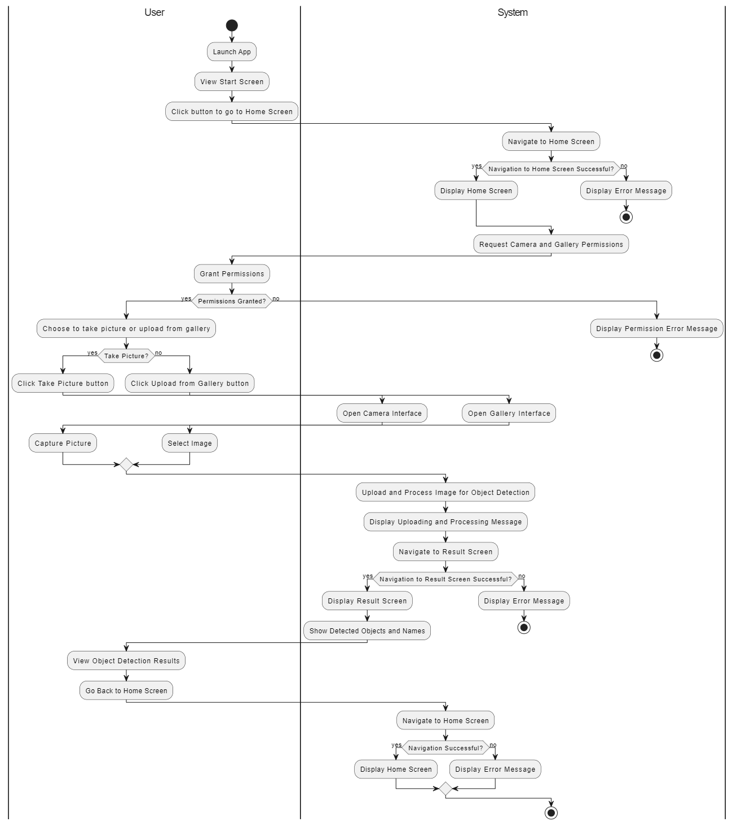
Figure: 3.3

Activity Diagram (Against each use case)

Use Case 1: Navigate to Home Screen

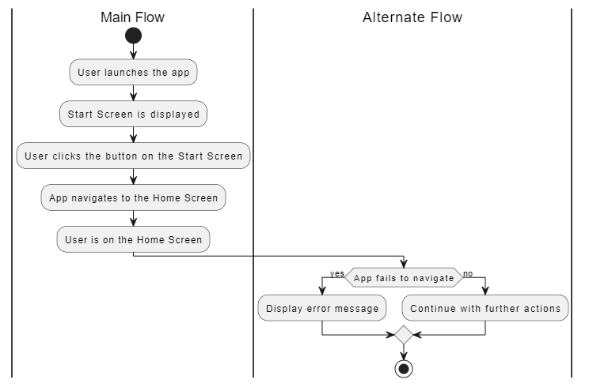
Figure 1

Use Case 2: Take Picture
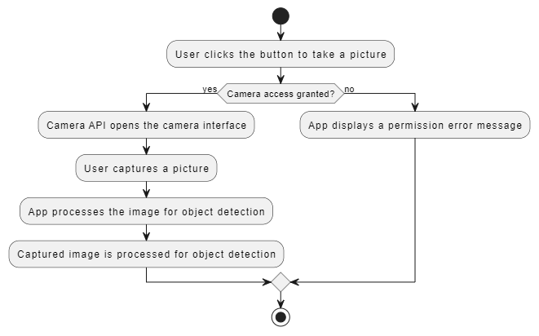
Figure 2

Use Case 3: Upload Image from Gallery
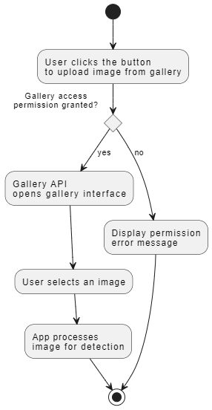
Figure 3

Use Case 4: View Object Detection Results
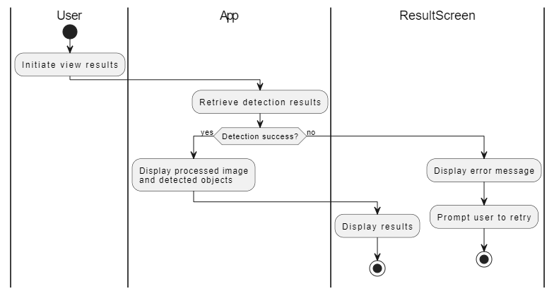
Figure 4

Use Case 5: Retry Object Detection
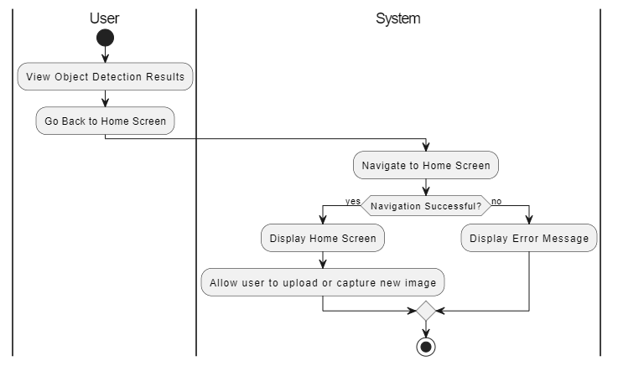
Figure 5

3.3.1: Activity Diagram Description
Activity | Performer | Description
Start | System | The user opens the app and navigates to the detection screen. UI initializes the camera/gallery handlers.
Capture or upload image | User / Mobile Client | The user chooses either: (1) Capture new image using camera, or (2) Select existing image from gallery. Input Handling module returns an image file.
Pre-process & Encode Image | Mobile Client | The image is compressed and encoded as Base64 or multipart/form-data. Client constructs an HTTP POST request to the detection API.
Send Image to Server | Mobile Network Module | The encoded image is sent to Django backend via REST endpoint /detect.
Receive Request & Validate | Backend Server | Django validates the request format, extracts the image content, and sends it to the Object Detection Module.
Run YOLOv8 Inference | Object Detection Module | YOLOv8 loads the image, preprocesses it, runs the detection algorithm, and produces bounding boxes, class IDs, and confidence scores.
Annotate / Serialize Results | Backend Server | Results are converted into either: (1) Annotated image, or (2) JSON structure containing labels, coordinates, and confidence.
Return Results | Backend Server | The server returns the response to the mobile app via a JSON payload or image file.
Display Results | Mobile Client | The app displays annotated image and a list of detected objects. UI highlights bounding boxes and confidence scores.
End | System | The process ends after results are displayed. User may choose to save, share, or perform another detection.

3.3.2: Flow Characteristics
- Real-time-oriented: Image upload and detection occur within seconds.
- Asynchronous handling: Client shows loading indicators while waiting.
- Error tolerance: The system handles low-confidence results or empty detections gracefully.
- Stateless communication: Each request is independent.

3.3.3: System Workflow Summary
- User provides the image.
- App prepares and sends it.
- Backend runs YOLOv8 inference.
- Backend returns results.
- App visualizes results.
This cycle ensures the system remains user-friendly while leveraging high-performance backend processing.

4

Design models

[Along with descriptions]

This chapter presents the complete set of system design models used to describe, analyze, and validate the internal and external behavior of the Check-Me application. These models provide a visual and conceptual representation of:
- The structural composition of the system
- The dynamic interactions between components
- The transition of states within the application
- The flow of data across different processing layers
Each model contributes to the overall design integrity and ensures that the implementation aligns with the architecture defined in earlier chapters.
Because the system uses an Object-Oriented Design approach, UML modeling techniques—such as Class Diagrams and Sequence Diagrams—are particularly suitable. For data transformation and process flow representation, Data Flow Diagrams (DFDs) give insight into how data moves through the system.

4.1:Class Diagram
The Class Diagram models the core logical components and their relationships within the application, particularly on the back-end (Django) and the data representation shared with the client.

Justification:
The system involves clear data entities (Image, DetectionResult, DetectedObject) and functional components (DetectionService, APIController). The Class Diagram provides a blueprint for the object-oriented implementation, showing how these entities are structured and related through associations (composition/aggregation).

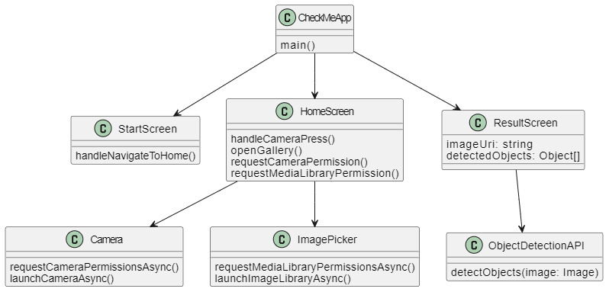
Figure: 4.1

4.2: Sequence Diagram (Against each use case)
The Sequence Diagram illustrates the temporal order of interactions between the primary actors and objects in the system during the main flow: The Object Detection Process.

Justification:
The process is inherently message-based, involving a clear set of steps (request, processing, response) across different architectural tiers (Mobile Client and Back-End Server). A Sequence Diagram effectively captures the timing and flow of network communication.

Use case 1: Navigate to the Home-screen

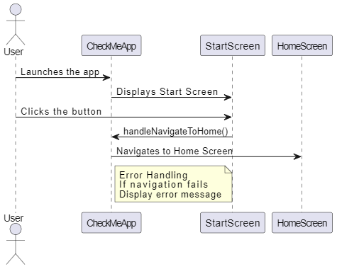
Figure 1

Use Case 2: Take Picture
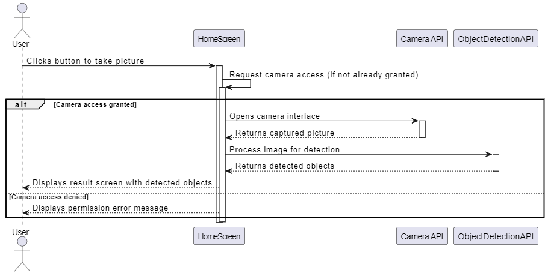
Figure 2

Use Case 3: Upload Image from Gallery
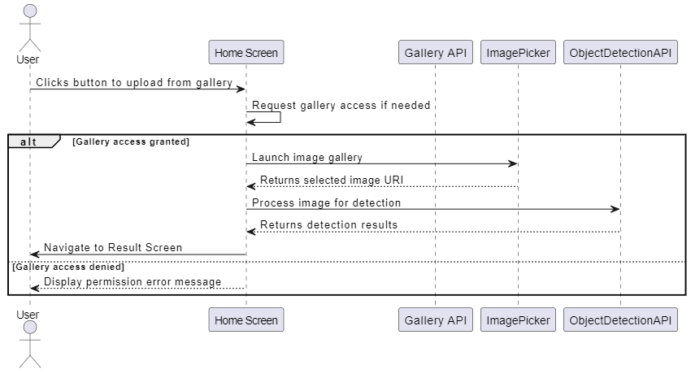
Figure 3

Use Case 4: View Object Detection Results
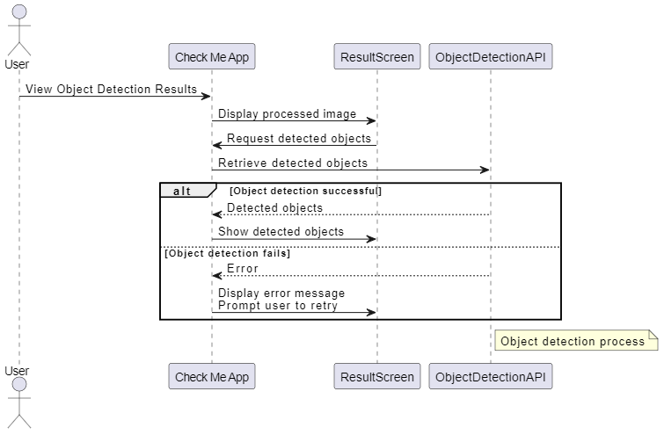
Figure 4

Use case 5: Retry object Detection

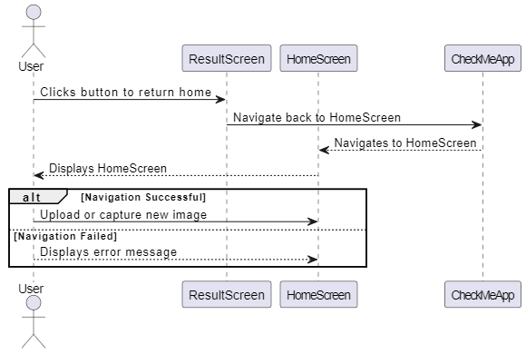
Figure 5

4.3: Flow of Messages:
- User initiates the process by tapping the "Detect" button after capturing/selecting an image.
- Mobile Client calls upload Image(image) on the API Controller. This is the HTTP POST request carrying the image data.
- API Controller validates the request and invokes the core service by calling run Inference(image_data) on the detection Service.
- Detection Service executes the machine learning algorithm (YOLOv8) to identify objects.
- Detection Service returns the raw detection data (bounding boxes, labels) to the API Controller.
- API Controller processes this raw data, creating instances of Detection Result and Detected Object, and serializes the final data into a clean JSON response.

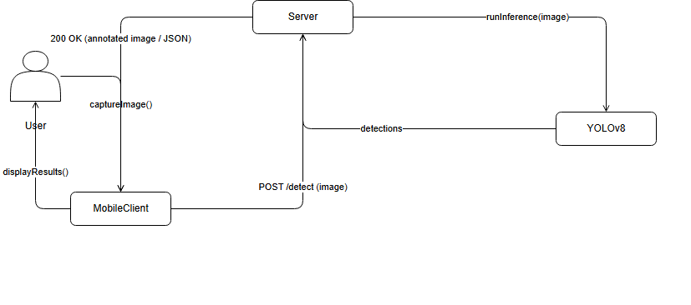
Figure: 4.3

4.4: State Transition Diagram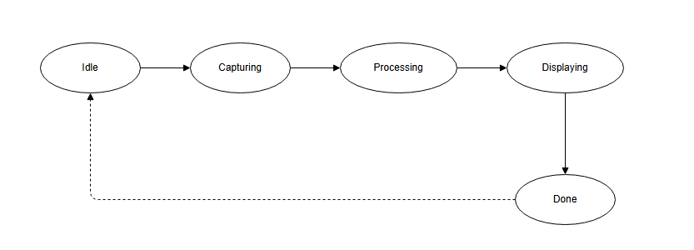
Figure: 4.4

4.5: Data Flow Diagram
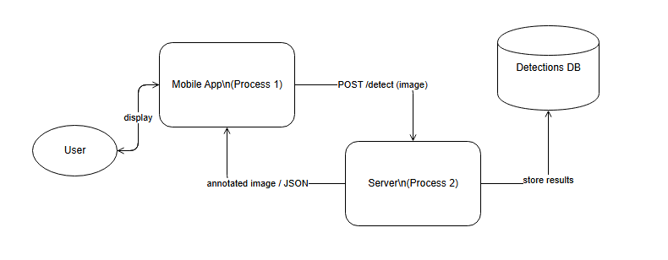

Figure 4.5

4.6: Schematic diagram (Hardware projects only)
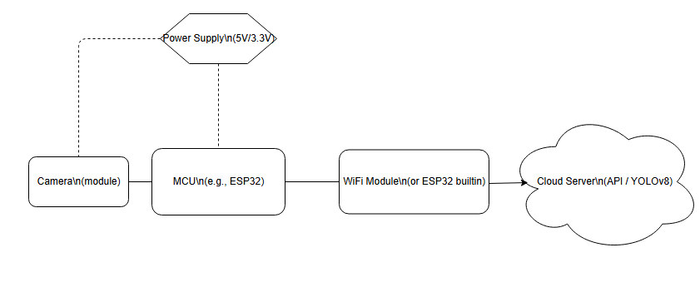

Figure: 4.6

4.7: Timing diagram (Hardware projects only)

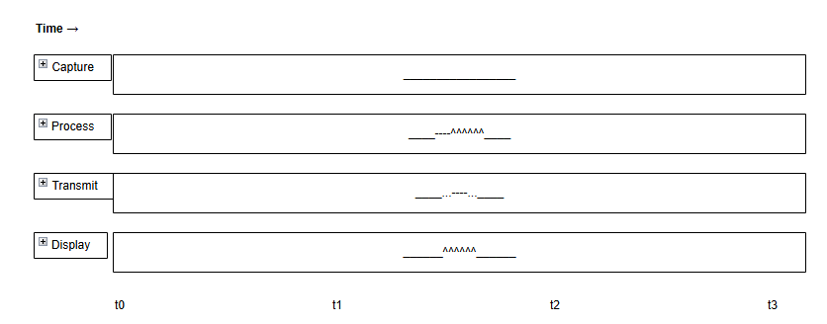
Figure: 4.7

5

Data Design

This chapter explains how the information domain of the system is represented, structured, stored, and accessed. The application processes visual data captured from the mobile device and transforms it into structured representations used for object detection, annotation, and display. The major data entities revolve around the image input, the detection results produced by the YOLOv8 model, and the communication payloads exchanged between the mobile client and the backend server.

The system uses two storage mechanisms:
- Transient-storage (In-memory-structures)
Used temporarily during processing, such as image buffers, NumPy arrays, YOLOv8 tensor outputs, intermediate annotation layers, and HTTP request payloads.
- Persistent-Storage
If required, the system can maintain logs or past detections in a database (e.g., SQLite/PostgreSQL).
This may include storing the original image, detected objects, timestamps, and user identification.
The data design ensures efficient transformation from raw image bytes to structured detection results that can be transmitted and rendered effectively on the mobile client.

5.1: Data Structures Overview

5.1.1: Image Data
Images captured or uploaded by the user are converted into:
- Byte Streams (raw binary image data)
- Base64 Encoded Strings (if necessary for transmission)
- NumPy Arrays / Tensors (for YOLOv8 inference)

5.1.2: YOLOv8 Detection Output
The YOLOv8 model outputs:
- Bounding Box Coordinates
- Class Identifiers (integer indices)
- Confidence Scores
- Labeled Names (mapped from class IDs)
These are stored in structured arrays or Python dictionaries before being serialized into JSON or used for annotated image generation.

5.1.3 API Request and Response Structures
The detection API handles:
- Incoming HTTP POST requests with image payload
- JSON responses containing detection results
- Image-byte responses when annotated images are sent back

5.2: Data Dictionary
Below is the alphabetically sorted data dictionary describing all major system entities, attributes, methods, and parameters.

Annotated Image
Type: Binary (JPEG/PNG)
Description: Image returned from the server with bounding boxes and labels drawn onto the original input.
Used in: Server response → Mobile Client display.

Bounding Box
Type: Object
Fields:
- x_min: float — Left coordinate
- y_min: float — Top coordinate
- x_max: float — Right coordinate
- y_max: float — Bottom coordinate
- confidence: float — Probability score
- class-id:int—YOLOv8classindex
Description: Represents the detected area of an object within the image.

Byte Stream
Type: Byte-array
Description: Raw binary representation of the image before preprocessing.
Used in: Mobile App → Server POST payload.

Class Label
Type: String
Description: Human-readable name mapped from YOLO class ID (e.g., person, cat, bottle).

Detection Result
Type: Object
Fields:
- boxes: List<BoundingBox>
- labels: List<ClassLabel>
- confidences: List<float>
- processed-at: date time
Description: Final structured output returned by YOLOv8 and serialized as JSON.

Detection Request
Type: HTTP POST Payload
Fields:
- image:Base64/String/Byte Stream
Description: Data sent from mobile client to server for processing.

Detection Response
Type: JSON/ Image Stream
Fields:
- detections: Detection Result
- annotated image: Optional<Binary>
- status: String
Description: Server response containing detected objects and processed image.

Image Base64
Type: String
Description: Base64 encoded version of the input image for safe transmission.
Used in: Mobile Client → Server.

Image Tensor
Type: NumPy array/ PyTorch Tensor
Description: YOLOv8-compatible numerical representation of the input image after preprocessing.

JSON Payload
Type: JSON-Object
Description: Structured results sent back by the server when annotated image is not required.

Mobile Client
Type: Software Component(Object)
Methods:
- captureImage()
- uploadImage()
- sendImageToServer(image)
- displayResults(response)
Description: Sends data to the server and displays detection results.

Processed Image
Type: Binary / Base64
Description: Image after annotation or transformation by the server.

Raw Image
Type: JPEG/PNG file
Description: Original unaltered image captured by user prior to preprocessing.

Server
Type: Software Component
Methods:
- receive Request(request)
- decode Image(bytes)
- run YOLO(image tensor)
- serialize Results(detections)
- return Response()
Description: Handles all backend processing and inference.

Stored Detection (optional if DB used)
Type: Database Entity
Fields:
- id: int
- user_id: optional int
- image_path: string
- detections: JSON
- timestamp: datetime
Description: Log of detections stored in database.

Tensor Output
Type: PyTorch / NumPy Tensor
Description: Raw output from YOLOv8 before conversion to bounding boxes and labels.

6

Algorithm & Implementation

This chapter explains the internal working logic of the system by breaking down each class and summarizing its key operations in structured pseudocode (PDL). Each component's functionality is described in a step-by-step manner to clearly demonstrate how the system processes input, executes computational tasks, and returns results.
The following subsections correspond to the core modules of the system as described in earlier chapters.

6.1 Core Algorithms (Object-Oriented Components)

6.1.1 Class: Camera Manager
Function: initialize Camera()
PDL:
FUNCTION initialize Camera():
CHECK if device camera is available
IF available THEN
configure camera resolution
configure frame rate
open camera stream
ELSE
return error "Camera not found"
END FUNCTION

Function: capture Frame()
PDL:
FUNCTION captureFrame():
READ latest frame from camera stream
CONVERT frame to required input format (RGB/BGR)
RETURN converted frame
END FUNCTION

6.1.2 Class: Image Preprocessor
Function: resize Image (image)
PDL:
FUNCTION resizeImage(image):
SET targetWidth = modelInputWidth
SET targetHeight = modelInputHeight
APPLY interpolation algorithm to resize image
RETURN resizedImage
END FUNCTION

Function: normalize(image)
PDL:
FUNCTION normalize(image):
FOR each pixel in image:
scale pixelValue = pixelValue / 255
RETURN normalizedImage
END FUNCTION
Function: prepare Input(frame)
PDL:
FUNCTION prepareInput(frame):
resized = resizeImage(frame)
normalized = normalize(resized)
convertToTensor(normalized)
RETURN tensorInput
END FUNCTION

6.1.3 Class: Object Detection Model
Function: load Model ()
PDL:
FUNCTION loadModel():
READ modelFile from storage
INITIALIZE model interpreter
ALLOCATE model tensors
RETURN status "Model Loaded"
END FUNCTION
Function: run Inference(input Tensor)
PDL:
FUNCTION runInference(inputTensor):
SET interpreter input to inputTensor
INVOKE model interpreter
READ output tensors: boundingBoxes, labels, confidenceScores
RETURN detectionResults
END FUNCTION

6.1.4 Class: Result Processor
Function: Filter Detections (results)
PDL:
FUNCTION filter Detections(results):
INIT empty list filtered
FOR each detection in results:
IF detection.confidence>= CONFIDENCE_THRESHOLD THEN
ADD to filtered
RETURN filtered
END FUNCTION

Function: annotate Frame(frame, detections)
PDL:
FUNCTION annotateFrame(frame, detections):
FOR each detection in detections:
DRAW rectangle on frame using bounding box
WRITE label and confidence on rectangle
RETURN annotatedFrame
END FUNCTION

6.1.5 Class: Storage Manager
Function: save Detection Log(detection Data)
PDL:
FUNCTION saveDetectionLog(detectionData):
OPEN database connection
INSERT detectionData (timestamp, objectName, confidence, location)
CLOSE database connection
END FUNCTION

Function: retrieve Logs (dateRange)
PDL:
FUNCTION retrieveLogs(dateRange):
OPEN database connection
QUERY logs WHERE timestamp BETWEEN dateRange
STORE results in logList
CLOSE database connection
RETURN logList
END FUNCTION

6.1.6 Class: User Interface Controller
Function: display Results (Annotated Frame)
PDL:
FUNCTION displayResults(annotatedFrame):
RENDER annotatedFrame on screen
UPDATE detection labels on UI overlay
END FUNCTION

Function: handle User Actions(action)
PDL:
FUNCTION handleUserActions(action):
SWITCH(action):
CASE "Start":
initializeCamera()
CASE "Stop":
stopCameraStream()
CASE "View Logs":
showLogs()
DEFAULT:
DISPLAY error "Unknown Action"
END FUNCTION

6.2: Overall System Flow (High-Level Pseudocode)
SYSTEM START
loadModel()
WHILE appIsRunning:
frame = captureFrame()
inputTensor = prepareInput(frame)
results = runInference(inputTensor)
filtered = filterDetections(results)
annotated = annotateFrame(frame, filtered)
displayResults(annotated)

IF logSavingEnabled THEN
saveDetectionLog(filtered)
END WHILE
SYSTEM END

7

Software Requirements

Traceability Matrix

This section maps each Functional Requirement (FR) and Non-Functional Requirement (NFR) to the corresponding design components described in this Software Design Document.
The traceability matrix ensures that every requirement has been addressed through one or more design artifacts such as class diagrams, sequence diagrams, DFDs, state diagrams, and component descriptions.

Table7.1: Requirements Traceability Matrix
Req. Number | Ref. Item | Design Component | Component Items
FR01 | Class Diagram | CameraManager | initializeCamera(), captureFrame()
FR02 | Class Diagram | ImagePreprocessor | resizeImage(), normalize(), prepareInput()
FR03 | Class Diagram | ObjectDetectionModel | loadModel(), runInference()
FR04 | Class Diagram | ResultProcessor | filterDetections(), annotateFrame()
FR05 | Class Diagram | StorageManager | saveDetectionLog(), retrieveLogs()
FR06 | Class Diagram | UserInterfaceController | displayResults(), handleUserActions()
FR07 | Sequence Diagram | Frame Capture & Inference Flow | Steps: Capture → Preprocess → Inference → Filter → Annotate → Display
FR08 | Sequence Diagram | Logging Flow | Steps: Detection → Save Log → Database
FR09 | DFD Level 0 | Main System Process | Inputs: Camera Feed → Processing → Output Display
FR10 | DFD Level 1 | Object Detection Pipeline | Functions: Preprocessing, Inference, Result Processing
FR11 | State Diagram | App State Flow | States: Idle → Camera Running → Detecting → Logging → Stop
FR12 | Data Dictionary | Entities & Attributes | Frame, TensorInput, DetectionResult, LogRecord
NFR01 | Design Constraints | Model Performance | Optimized inference using TFLite
NFR02 | Design Constraints | Usability | UI updates in real-time under UIController
NFR03 | Design Constraints | Reliability | Database logging via StorageManager

8

Human Interface Design

This chapter explains the system’s functionality from the user's viewpoint. It describes how users interact with the mobile application, how they navigate through screens, and what feed back the system provides.
It also outlines the layout of each major screen, the purpose of interface elements, and how users perform actions using these components.

8.1: Screen Images

Screen 1: Splash Screen
- App logo and name displayed in the center.
- Automatically transitions to the Home screen.

Screen 2: Home / Detection Screen
Camera preview area or placeholder panel.
- Two main buttons:
  - Capture Image
  - Upload from Gallery
- A small menu icon for settings (optional).

Screen 3: Processing Screen
- Spinner or progress animation.
- Text indicator: “Detecting objects…”
- Disabled interactions until processing is complete.

Screen 4: Results Screen
- Annotated image with bounding boxes.
- List of detected objects with:
  - Name
  - Confidence score
- Buttons:
  - Save Result
  - Retry Detection
  - Back to Home

Screen 5: History / Logs Screen
- List of saved detection logs.
- Each item shows:
  - Thumbnail of the image
  - Date & time
  - Summary of top detections
- Tap to view detailed results.

8.2: Screen objects and actions
Below is a detailed description of each UI element and the associated user actions.

8.2.1: Splash Screen
Screen Object | Action | Description
App Logo | None | Displayed briefly when app opens.
Progress/Delay | Auto-navigation | Automatically moves to Home screen after 2–3 seconds.

Figure 1

8.2.2 Home / Detection Screen
Screen Object | User Action | System Response
Camera Preview Panel | User views live camera feed | Shows real-time camera input.
Capture Image Button | Tap | Opens camera → captures image → sends for preprocessing.
Upload Image Button | Tap | Opens file picker → user selects gallery image → app sends for detection.
Menu / Settings Icon | Tap | Opens app settings (optional).
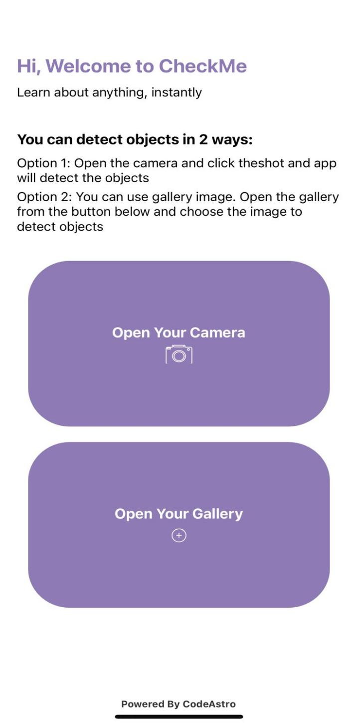
Figure 2

8.2.3 Processing Screen
Screen Object | User Action | System Response
Loading Animation | None | Shows processing status.
Processing Text | None | Indicates detection is running.

8.2.3: Results Screen
Screen Object | User Action | System Response
Annotated Image View | View | Displays image with bounding boxes and labels.
Detected Items List | Scroll | Shows detected object names and confidence values.
Save Button | Tap | Stores image + results in local history/database.
Retry Button | Tap | Returns to detection screen for a new image.
Back Button | Tap | Goes back to Home screen.
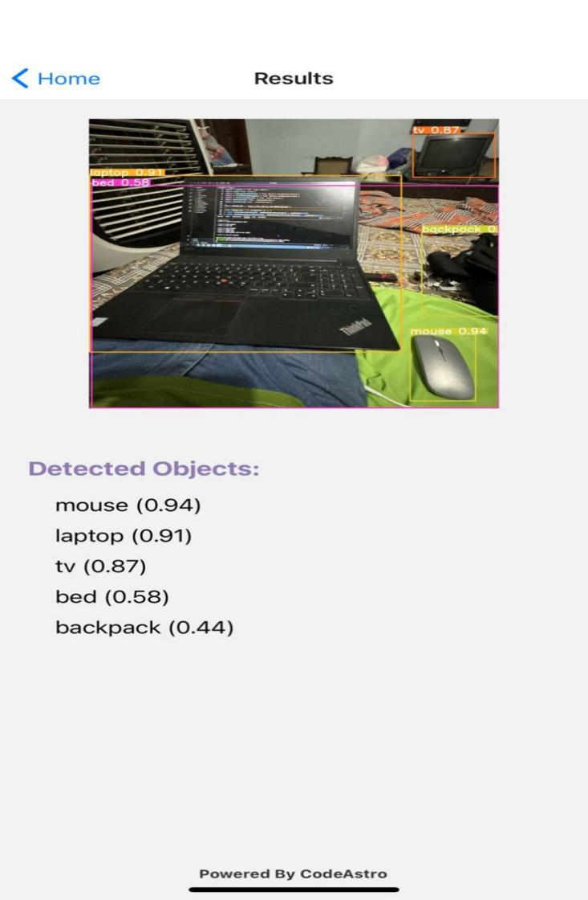
Figure 3

8.2.5 History / Logs Screen
Screen Object | User Action | System Response
Log List Items | Tap | Opens previous detection with full details.
Thumbnail Image | Tap | Enlarges image.
Clear All Logs Button | Tap | Deletes logs after confirmation prompt.

9

Appendix I

This appendix provides reference material and guidance resources that support the modeling, diagramming, and design activities used throughout this Software Design Document. These references help ensure that all diagrams and design techniques follow established software engineering standards and best practices.

9.1: UML (Object-Oriented) Design Guidelines
- For creating UML-based object-oriented design artifacts such as:
- Class Diagrams
- Sequence Diagrams
- State Machines
- Activity Diagrams
- Use Case Diagrams
- Component Diagrams
- Refer to the following comprehensive resource:
Link:
http://agilemodeling.com/artifacts/
This site explains the purpose, structure, notations, and best practices for each UML diagram, along with detailed examples and modeling guidelines.

9.2: ER Diagram Design Guidelines
- For projects that involve data modeling or relational database design, Entity–Relationship (ER) diagrams may be required.
- Use the following reference for complete guidance on:
- Entities
- Relationships
- Keys and attributes
- Normalization concepts
- Mapping ER diagrams to relational schemas

Reference:
The Complete Book (Ullman)
Link:http://people.inf.elte.hu/nikovits/DB2/Ullman_The_Complete_Book.pdf

9.3: Data Flow Diagram (DFD) Guidelines
- For projects using Data Flow Diagrams (DFDs), the following resources provide complete guidance on:
- Context Diagrams (Level 0)
- Decomposition into Level 1 and Level 2 processes
- Data stores
- Data movement between system components
- DFD rules and notations
Links:
http://www.agilemodeling.com/artifacts/dataFlowDiagram.htm
Software Engineering – A Practitioner’s Approach by Roger Pressman
These sources offer detailed examples, modeling techniques, and formal notation guidelines.

9.4: Architecture Diagram Guidelines
To design system architecture diagrams (e.g., layered architecture, client–server architecture, microservices, or component allocation diagrams), refer to:
Reference:
Ian Sommerville – Software Engineering (9th Edition), Chapter 6
This chapter explains:
- Architectural patterns
- Architectural styles
- System decomposition
- Interface specifications
- Structural and behavioral views

